OCHIN-ADVANCE PATIENT AND CAREGIVER engagement values, functions, and metrics

Version 5, 15 October 2024

**Core values, central practices, and engagement metrics in OCHIN-ADVANCE:**

1. Integrate patient and caregiver experience and expertise
   * Develop and maintain sustainable, adaptive mechanisms for patient and caregiver input, consultation, collaboration, and/or partnership:

* In the research process (e.g., Patient Engagement Panel, patient advisors or study panels, affiliate practice-based research networks)
* In network governance and development (e.g., ADVANCE patient investigator, Patient Engagement Panel)

1. Elevate patient and caregiver experience and expertise
   * Support patients and caregivers with baseline and ongoing training and learning resources to strengthen research understanding and input
   * Train and support research project teams and investigators in eliciting, maintaining, and integrating patient and caregiver collaboration and input to research
2. Implement changes
   * Implement patient and caregiver feedback suggested changes, or other input to research activities, and practices
3. Report impact
   * Document implementations, adaptations, feedback not included
   * Report back to patients and caregivers contributing to proposals, projects, or network related activities

* How contributions were integrated including any changes or adaptations
* Known or anticipated impacts (e.g., improved patient centeredness, priority alignment)

1. Collaborate on proposal development
   * Establish clear expectations and processes to integrate patients and caregivers in proposal development. Key points for involvement in proposal development include describing the topic area or research need, framing of the research question and associated outcomes, engagement and recruitment methods, and community-oriented (non-academic) dissemination.
   * Prioritize patient and caregiver involvement in proposal development as Patient Investigators for projects with higher levels of engagement and recruitment complexity, especially those that include patient-reported or person-centered outcome measures
2. Collaborate on engagement and recruitment approaches
   * Involve patients and caregivers in engagement and recruitment planning, implementation, evaluation, and learning

* Consult or collaborate on recruitment materials and approaches as well as data collection tools and methods based on study settings, topic areas, and communities/populations of interest
  + Share engagement and recruitment materials and approaches among partners, collaborators, and network members

1. Engage patient and caregiver collaborators with relevant lived experiences
   * Maintain and develop diverse PEP membership to provide representation from communities and health experiences across the OCHIN and ADVANCE networks
     + Regional location (northeast, southeast, midwest, northwest, southwest)
     + Age
     + Race and ethnicity
     + Sexual orientation and gender identity
     + Health conditions, especially chronic conditions
     + Caregiving
     + Insurance status
   * Align patient investigator, panelist, and advisor experiences and interests with project topic areas or engagement and recruitment approaches
   * Apply multiple recruitment approaches including peer-to-peer, outreach through member health centers, word of mouth with research partners and collaborators, direct outreach to member or partner patient and caregiver advisory groups
2. Measure engagement together
   * Incorporate patient and caregiver feedback in selecting and setting metrics
   * Gather individual feedback and input on patient and caregiver engagement and PEP operations on at least annual basis with priority partners:
     + PEP members
     + Patient investigators (if not on the PEP)
   * Report back on engagement activities and infrastructure to patients and caregivers, project teams, and funders on a regular basis (at least annually)

**Figure 1: Patient and caregiver engagement functions and metrics**

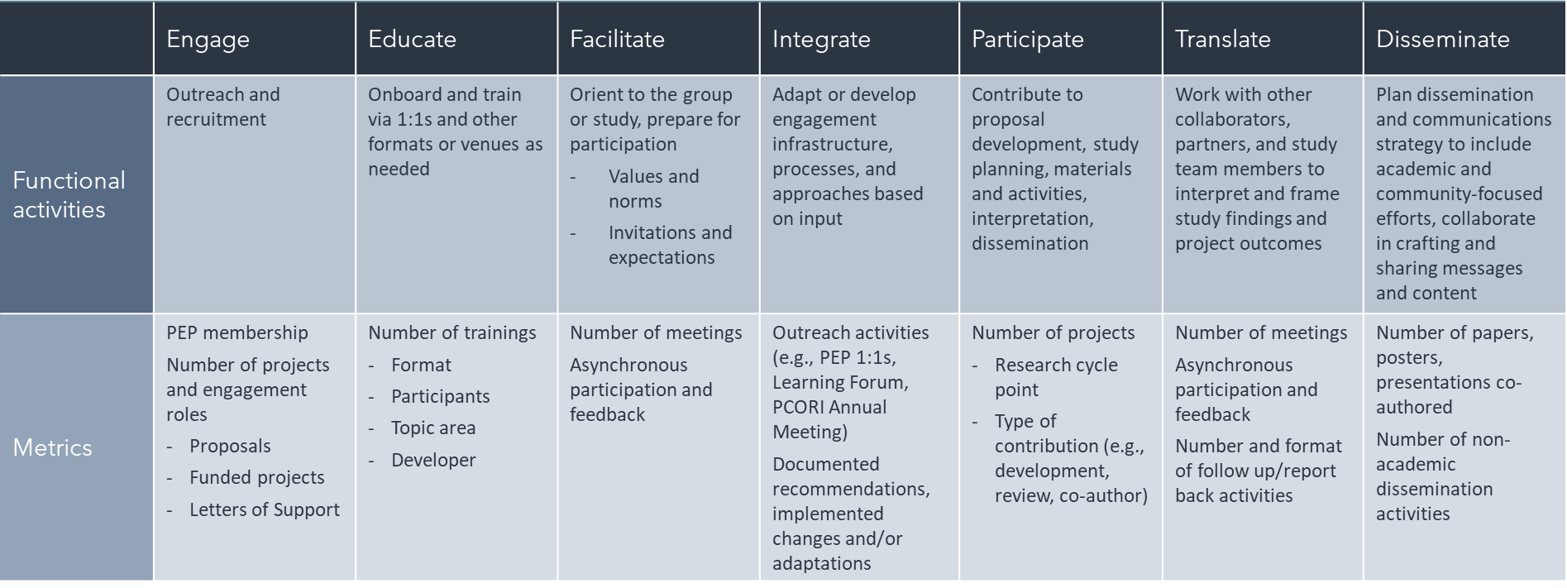

**Contact information:**

Anna Templeton, ADVANCE Engagement Lead – [templetona@ochin.org](mailto:templetona@ochin.org)